Photo Assignment

Mikko Karkkainen

# Galvanic Corrosion on a steel weld seam

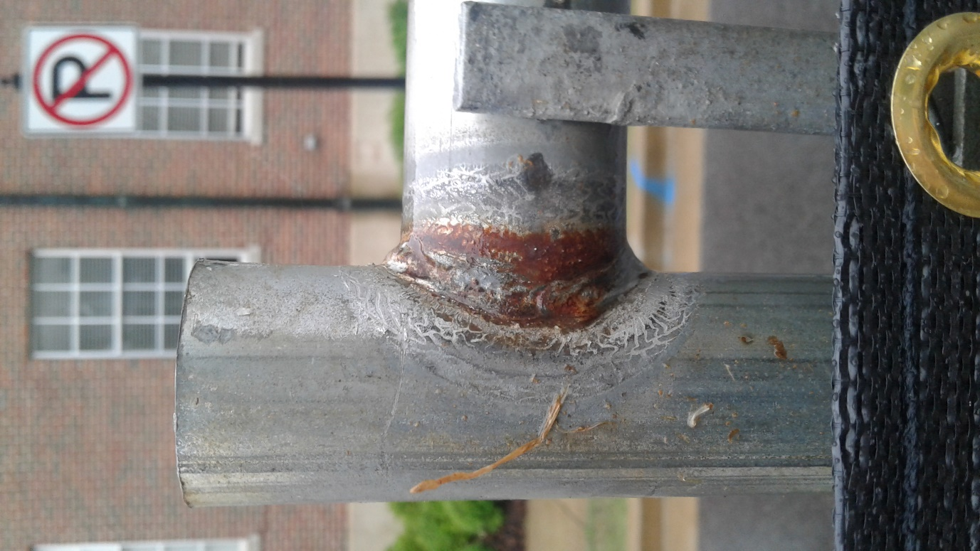

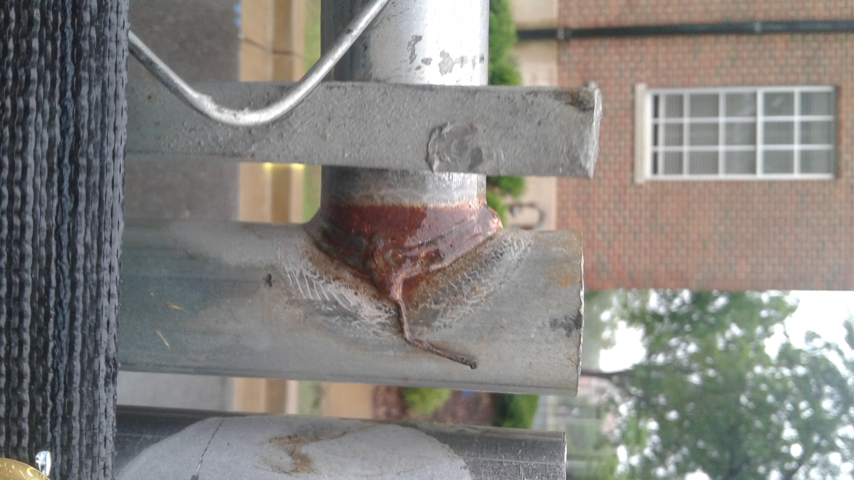

Figure 1. Weld in construction fence outside NERC. No coating is apparent.

The HAZ (heat affected zone) of the weld acquire different electrochemical activity from the bulk due to segregation of alloying elements into the welding liquid pool. The potential difference between the HAZ and the surrounding unaffected stainless steel forms a galvanic pair. As an example, this can specifically be a problem for stainless steel products, where the heat can cause the precipitation of chromium carbide. If the chromium content of the primary phase drops below approximately 10%, the stainless steel loses its corrosion resistance. However, the fence material is almost certainly not stainless, so the difference in concentration of some other element than Chromium may be causing an issue.

Small crevices and microcracks found in the weld also cause localized corrosion, due to the formation of an oxygen corrosion cell. When the crevices are filled with rain water, depletion of oxygen in the crevices causes a potential difference between the outside of the crevice and the inside, creating an oxygen concentration cell.

My guess is the material is medium-carbon pearlitic steel due to its application. Such steel is inexpensive, so it makes a logical choice. It doesn’t make sense to reduce the carbon content to a low level or add any expensive alloying elements or treatments since these treatments are expensive and only required for applications requiring high strength. The steel is likely not austenitic or martensitic for the same reason.

The cathodic reaction:

Anodic reaction: